Top 5 reasons to hire Ida...
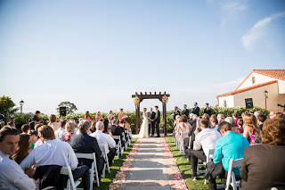

1. Save Time
Ida has a lengthy list of professional vendors and creative venues, which can eliminate weeks of legwork and phone calls. She can help plan each detail of your event efficiently with reliable resources. She can gently walk you through every stage of the planning process to ensure that very detail is tailored to your specific needs.

2. Save Money
Working with Ida as your coordinator saves you money in many areas. Ida will help you stay within your budget by finding vendors in your price range without compromising quality. She will negotiate for you to reduce costs and suggest alternative solutions. She will review contracts and setup a payment schedule to allow you to achieve the event of your dreams.

3. Organize Everything
Ida is an experienced event manager who understands the intricacies of scheduling a special event that runs smoothly. Her proactive, solution-focused abilities will allow you to enjoy your day and all that leads up to it.

4. Act as a Mediator
Ida is an experienced, unbiased third party to turn to for answers and advice every step of the way.

5. Relieve Stress & “Day of” Management
Ida will assist you in the planning. You do not have to handle the burden yourself or rely on your family, friend or co-worker. Let Ida make sure your entire day run perfectly & smoothly.

